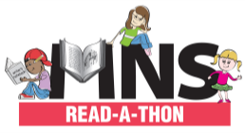
MNS READ-A-THON CHALLENGE LIST
Sunday, March 1st – Sunday, March 15th

Name: __________________________________________________
Teacher/ Grade: __________________________________________

In addition to books(s) of my own choosing, I pledge to read 5 books from the list below:
- A book published this year
- A book you can finish in a day
- A book you have been meaning to read
- A book recommended by a teacher
- A book chosen for you by a family member or friend
- A book published before you were born
- A book that you have started but have not finished
- A book that has animals on the cover
- A non-fiction book
- An award-winning book
- A book about a character from another country
- A book that has a non-human main character
- A book or collection of poems

Please submit completed sheet of 5 activities to your teacher by Wednesday, March 18th to be entered into our raffle.

